Dear Kate Vasquez
Another year is soon to pass and we are sorry this has been very hard for you all.
Caroline and I look forward to continue our support for you.
We hope all your family are keeping safe and well for it is so important and keep focused on personal safety to beat this virus.
Our family are all well and we will not see very much of them over Christmas due to the many restrictions still place.
Ethan is our youngest grand child and will be three in January and he can get confused why we can not hug him or see him more. His Mother Karen came to Ecuador to visit the project around 10 years ago with her friend Raquel, Raquel mum is Marion Gardner whom you may well know. After Karen’s visit we also got involved to support you.
Today Caroline and I went for a long walk along a beach in winter sunshine. There were lots of people walking with their dogs and everyone keeping a safe distance from each other.
We wish you and all your family a merry Christmas and pray that you all stay safe

Happy Christmas
Iain and Caroline

Dear Nixon!
Many thanks for your message. We marveled at your picture: you look now so mature!
We are pleased to hear that you and your family are well. Good to hear that you are studying hard at home. My sons have to do the same just now. We are all in quarantine after first the little foster boy Erik than me tested positive for Covid19- thankfully with only very mild symptoms. From 16.12.20 Germany will go into lockdown again. So it will be a rather quiet Christmas. We are thinking of singing Xmas carols from our balcony. Lets see if anyone from our 11 storey block will join in.
Hope you and your family stay well. May the joy of Christmas be with you all.
Thinking of you
Anne
P.S. The picture is from our holiday at the windy Baltic Sea
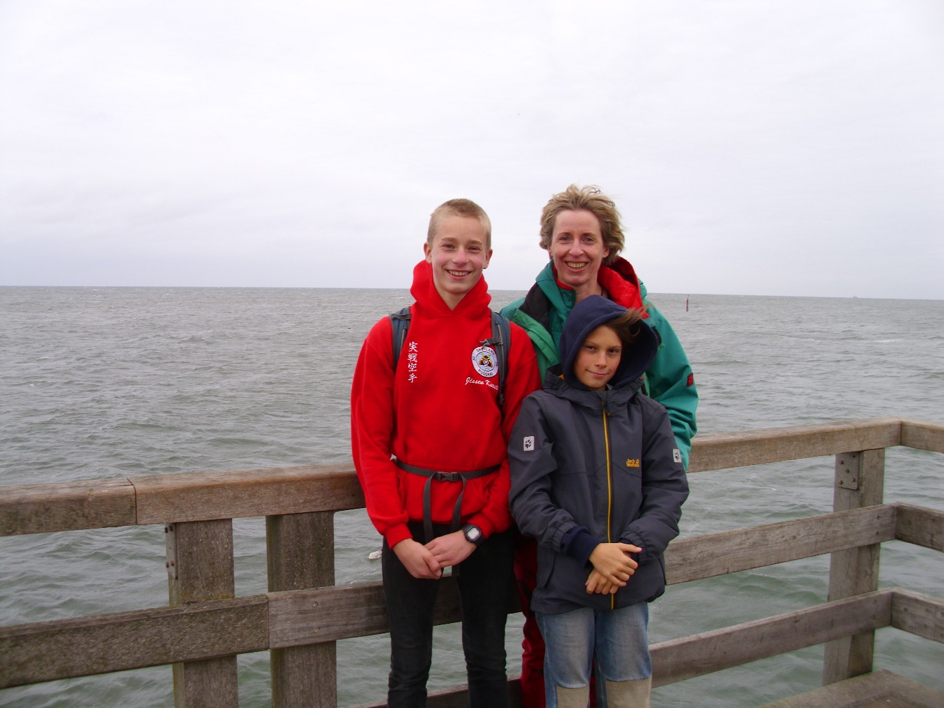

Dear Matias Burgos
So lovely to hear from you. I am so glad that you and your family are safe and free from the virus.
I am a school nurse and we have had lots of cases recently. Fortunately my family and I don’t think we have been affected yet. I have a husband called Dan and 2 boys aged 6 and 4 years. They have been back to school since the summer.
Wishing you a peaceful and blessed Christmas.
God bless you
With love
Gemma

Hi Kristel
So pleased to hear from you and to hear you are safe and well and staying home doing your lessons.
We also have stayed at home since March trying our best to keep away from the virus.
We are in the winter Season here in Shetland, so it’s quite cold. We have started with a vaccine programme for Covid so hopefully that will reach everyone very soon.Our grandchildren are all back at school and studying hard, we have 11 grandchildren.
Hopefully life will get back to normal very soon and you will be able get back to school and see all your friends.
We will be spending Christmas in our own home and not visiting our son or daughter and families so we can all stay safe and we hope and pray next year will be better.
Trust you stay well and keep up with your studies and look forward to news on how you are doing.
Love and blessings
Elizabeth and John

To Juliana
Wishing you a Very Happy Christmas and God's blessing in 2021
It was good to receive you letter, and we do hope that you and your family are keeping safe from the Covid virus. We pray for you, and hope you and your friends will be able to get back to your studies before long.
With our love,
Harry and Frances Godden.

Dear Erika,

We write to you to wish you a very happy Christmas.

We hope that you and your family are all well and that you are looking forward to spending some happy times together at Christmas.

We are so thankful for the the most precious gift of all, Jesus Christ our Lord and Saviour, who loves you very much.

We hope you enjoy your gift from us and have a lovely Christmas.

With love and prayers from

Paul & Morag XXX

Hello Deneric

How are you? Hope you are finding things to do while you can’t be at school. My grandchildren are about your age and they have had to miss a lot of school too. Sometime they get on with work at home.

It’s very wet here today – it has rained all day, and we might even get snow. I don’t know if you get snow in Ecuador? I love to see the snow, but it can be a nuisance when you want to go somewhere and the roads are too blocked. We went on a long walk this morning and delivered some Christmas cards to our friends. Do you still like playing football, and drawing? My grandchildren love drawing and colouring in. One of them loves dancing and one goes to Scouts. That is a fun thing to do – they play games and make things in craft. One of them, Benji, goes to football training and really likes it.

My granddaughter Lucia has just been asked to play Mary, Jesus’s mother, in the nativity play at our church. She will have to find a costume and learn her words. She is very excited about it.

Well, it’s nearly Christmas time, and I want to wish a very happy Christmas to you and your family.

With love from Jean and Rob x x

Dear Matias Herrera,

We want you to know we are thinking about you and your family and pray for you every day. We received your school report and you are doing so well! Well done!

We want to wish you every blessing at this special time of year when we celebrate Jesus' birthday. We hope you can be with all of your family. I'll attach a photo of our family.

God bless and keep you,

Love from Liz and Malcolm Adamson. xxx
